

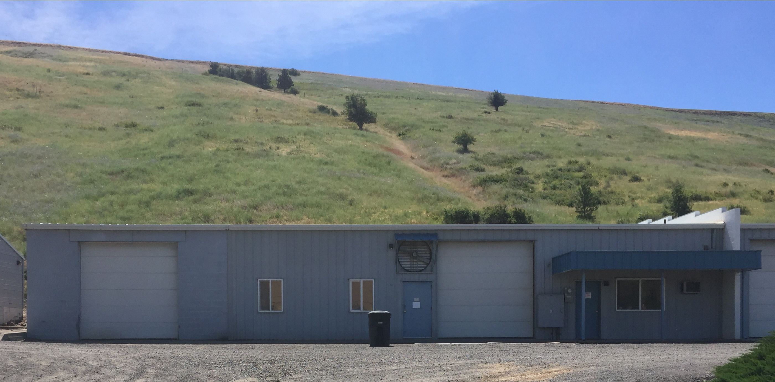



Contact Kathryn at the Port of Columbia at 509-382-2577 or email [kathryn@portofcolumbia.org](mailto:kathryn@portofcolumbia.org) for more information on leasing this space.

**3 Port Way for Lease – Available March 15, 2019**

The Port of Columbia's Rock Hill Industrial Park is located on the west end of Dayton, WA adjacent to Highway 12 and is home to 14 businesses. The following are specifications for 3 Port Way:

* 4,150 sq. ft.
* Zoned Light Industrial
* Mezzanine Load capacity of 80 lbs per sq. ft.
* 2 – 12’ Overhead Doors
* 12’x20’ office space
* Separate bathroom with sink
* Additional sink in work area
* 12’x20’ storage above office space
* Floor drain
* Ample 110 and 220 voltage outlets distributed throughout space
* Approximately 23’x50’ area separated by wall with single access door
* Updated HVAC system
* **Lease rate - $789.88 per month** (includes 12.84% state leasehold tax) **plus utilities.**